Input : BRD as per given format :

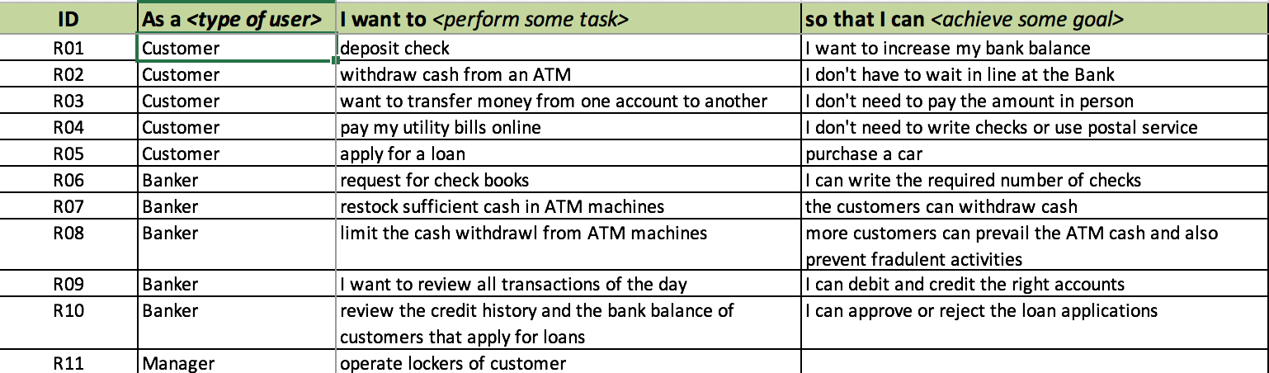

Output provided in JSON format :

Actually there are 2 types of representation for output :

1. Using NLTK Grammar based approach

Where we are using an inbuilt function nltk.RegexpParser()

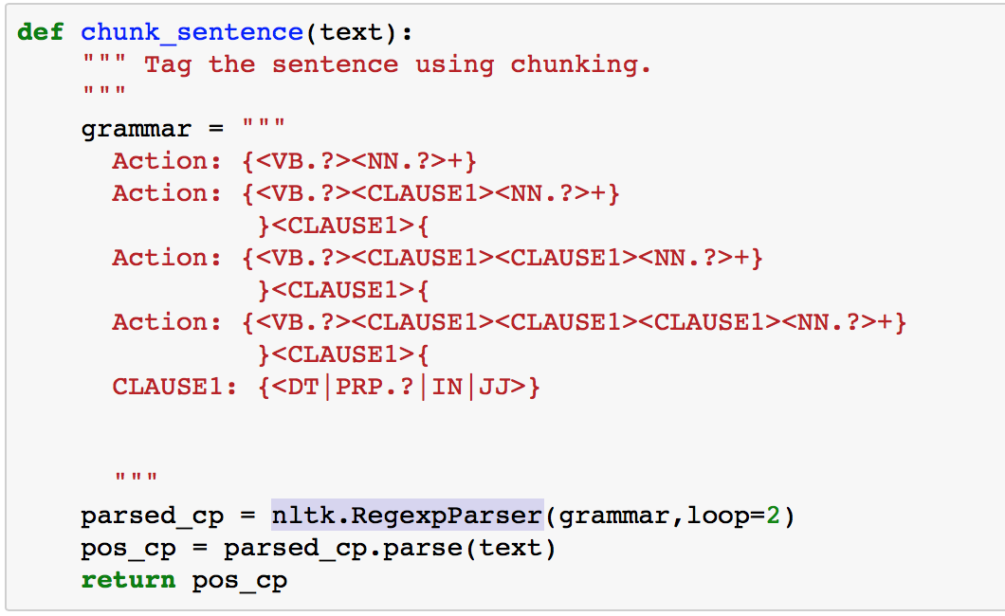

1. Using a rule based approach where chunking and chinking parts of sentences are identified using a JSON based rule.

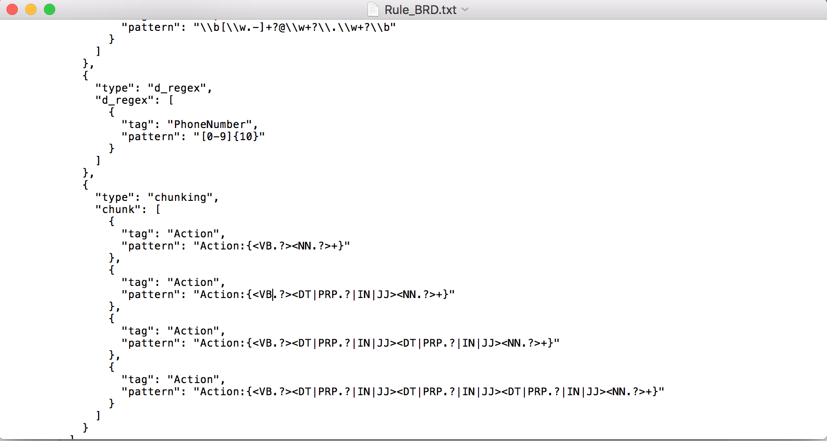

Output will be a json file format which will be easy to handle for subsequent processing :

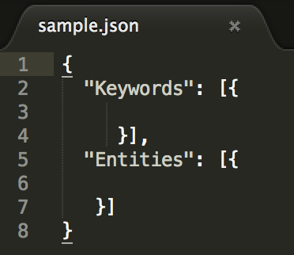

It will have 2 sections

1. Keywords – under which it will show what <USER> will be doing action.
2. Entities – under this it will show which <ACTION> will be performed

**Actual Output :**

Output 1 :

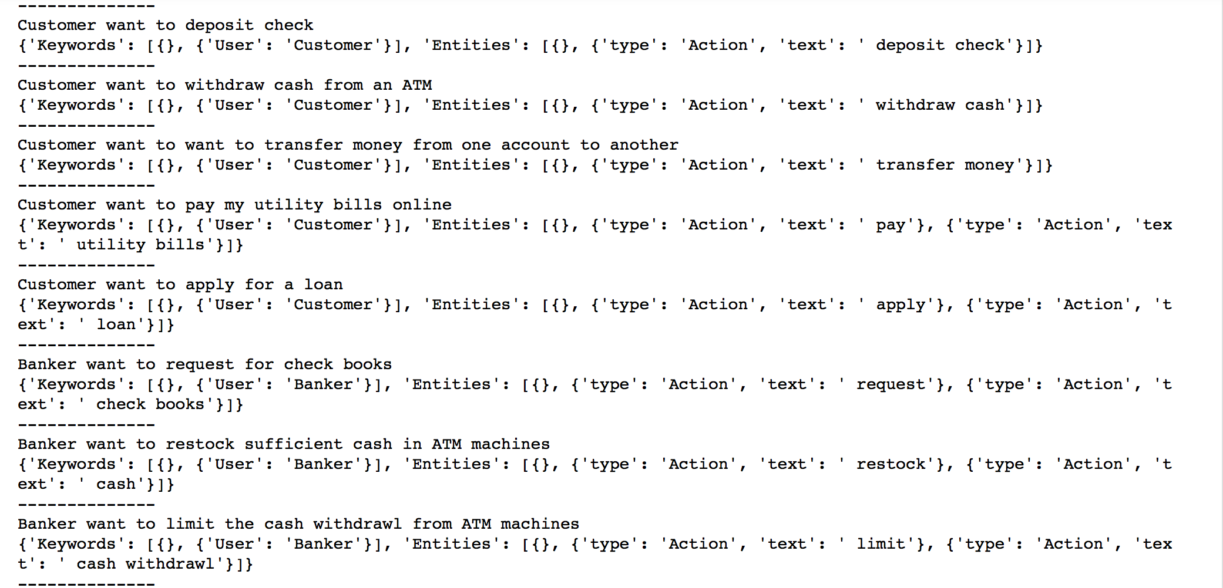

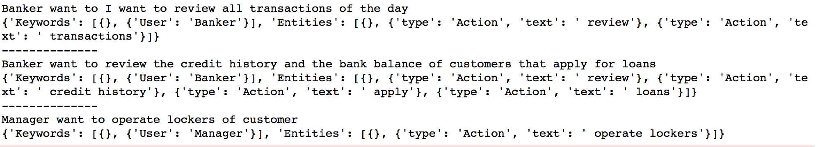

Here as you see Keywords shows the data type as User and text shows the type of user i.e Banker,Customer,Manager etc

Under Entities we see the type of entity which is “Action” and under text it shows the kind of action one needs to perform i.e review, transaction or operate lockers

So in ex : Banker wants to Limit cash withdrawal from ATM machine

User is Banker

Action is : limit cash withdrawal.

Output 2 :::

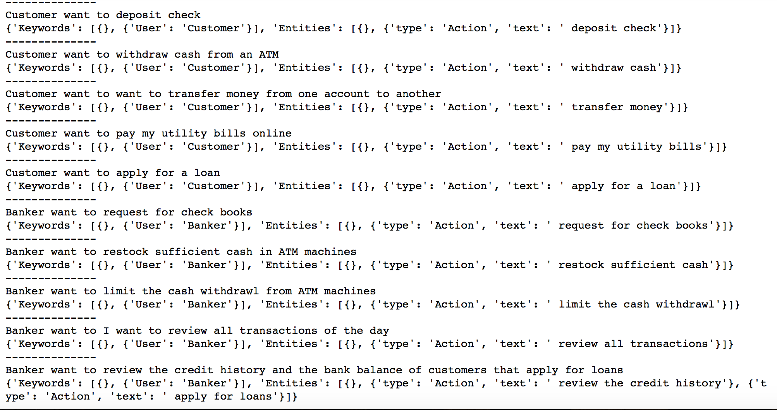

Here the under Keyword

User is Banker or Manager or Customer etc

Under Entities

Action performed is the entire chunk of words. i.e Action is apply for a loan or limit cash withdrawal etc.

Here the limitation is I cannot chink the portion, from the chunked part of sentence as json is not allowing the format.